# CS 255 System Design Document Template

## UML Diagrams

### UML Use Case Diagram

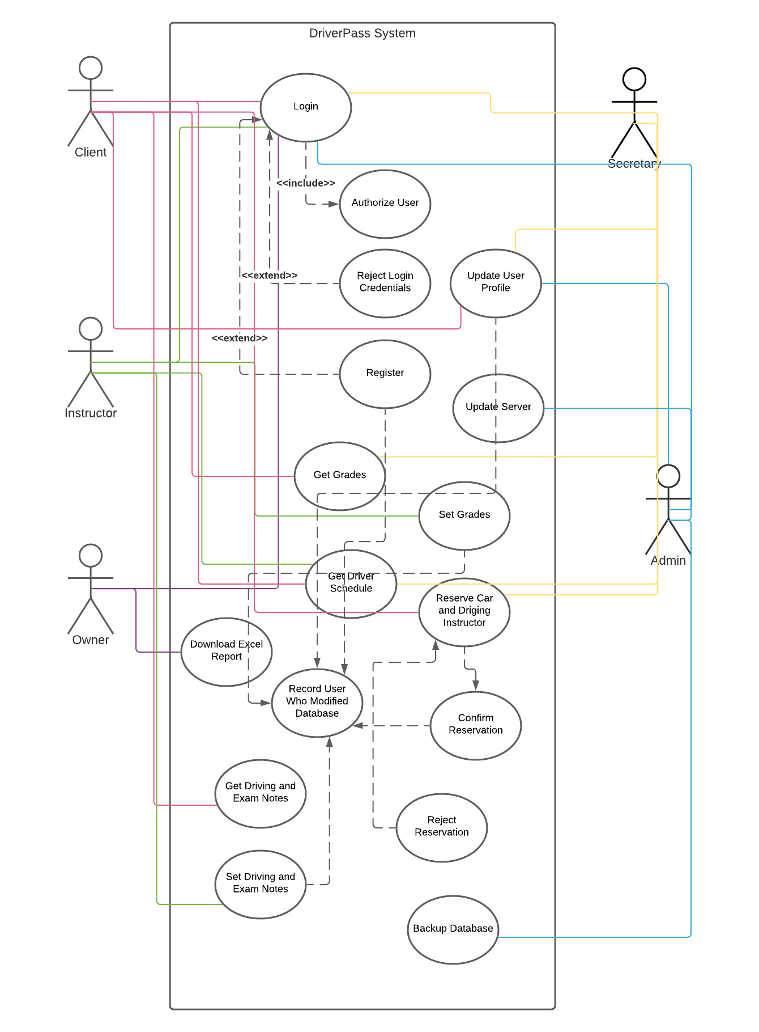

### UML Activity Diagrams

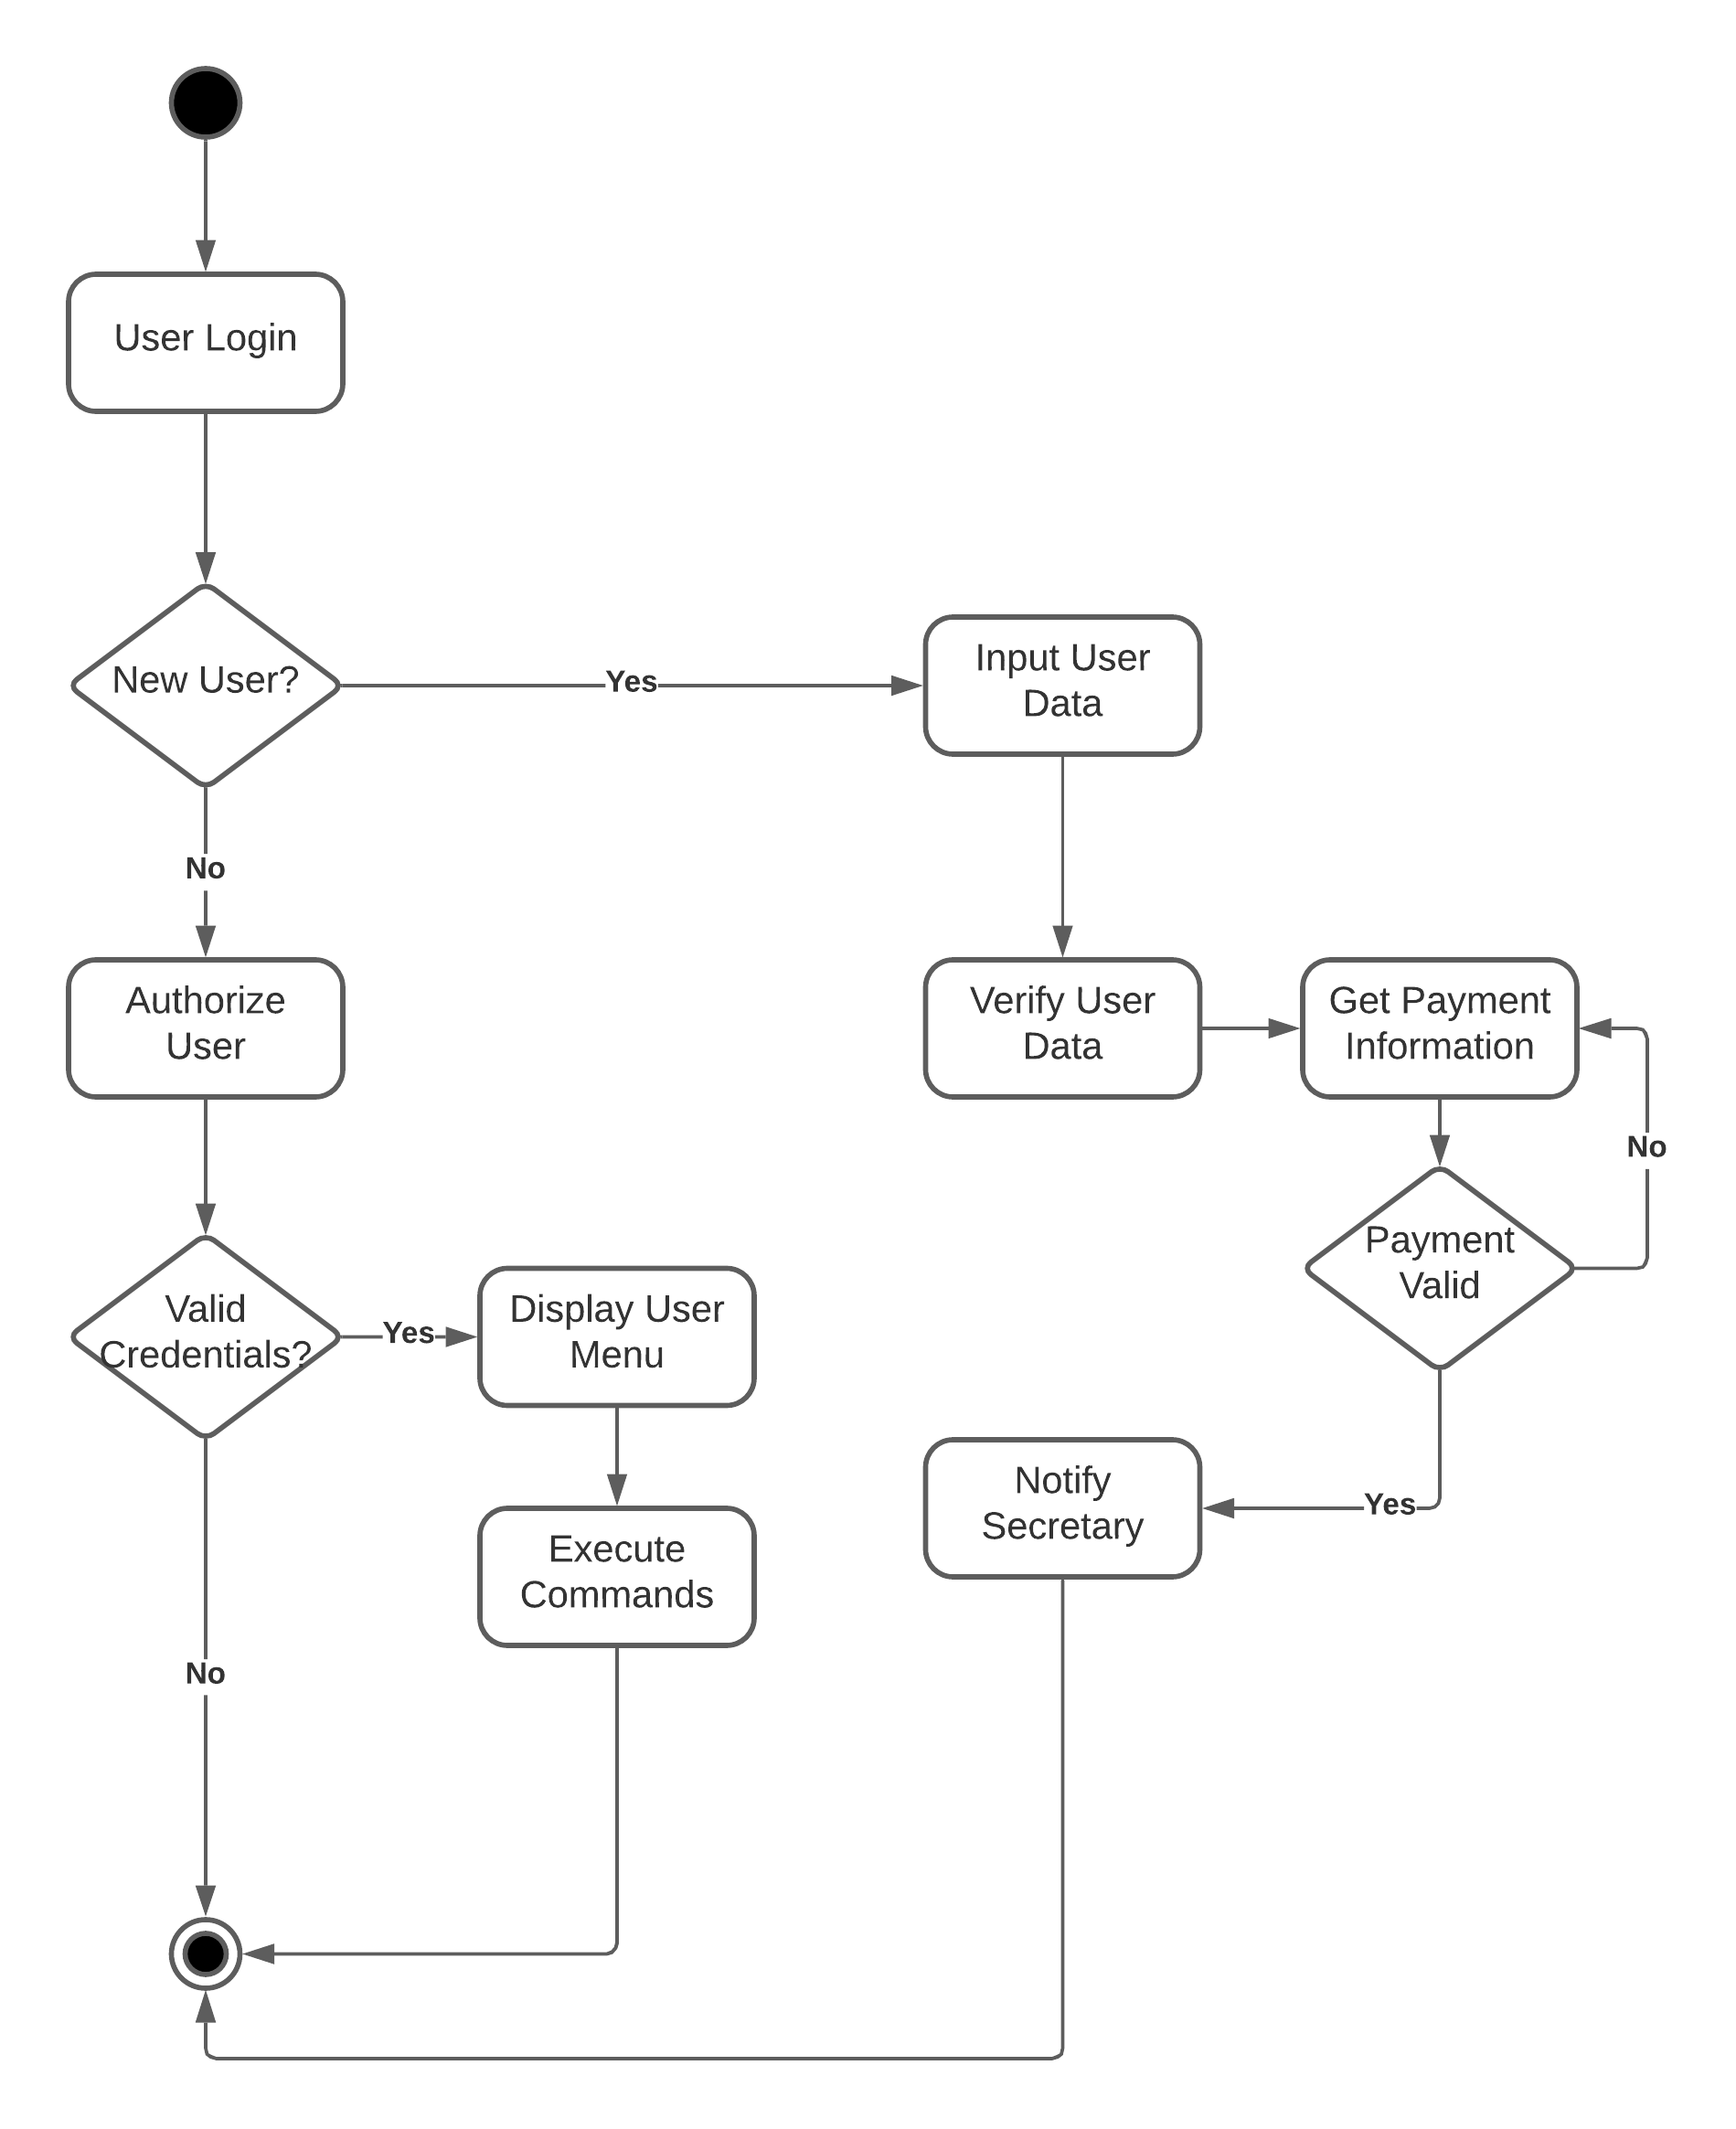

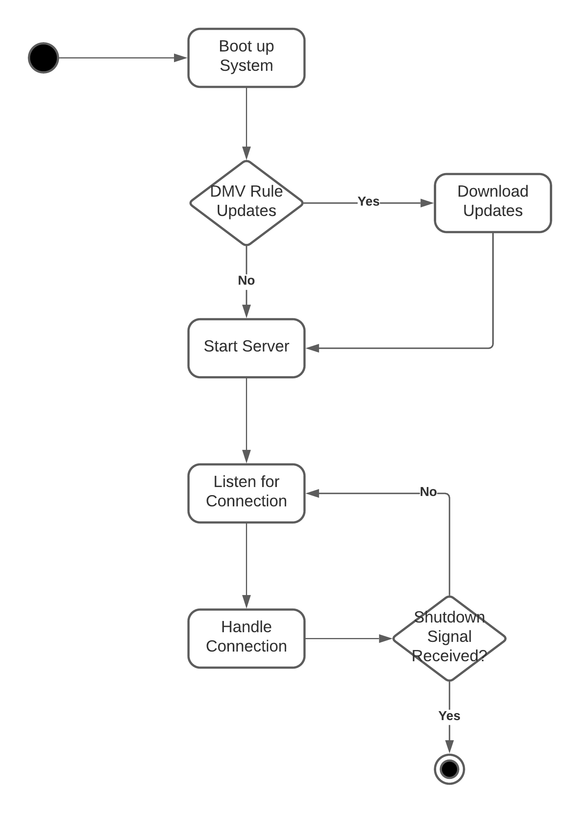

### UML Sequence Diagram

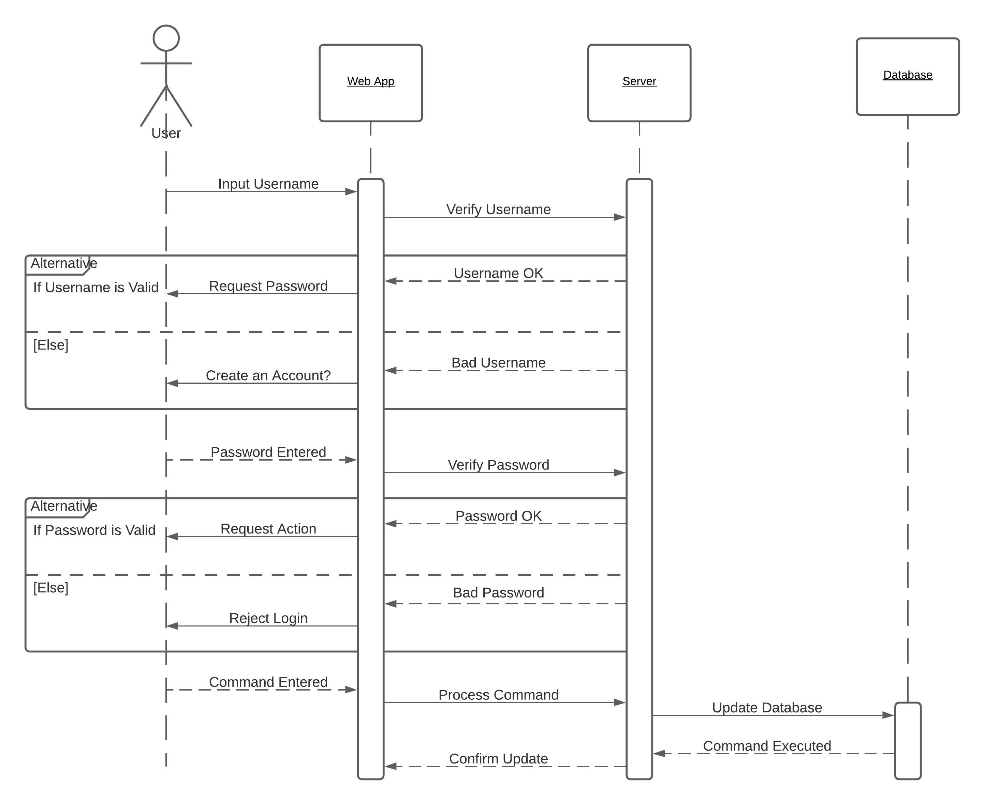

### UML Class Diagram

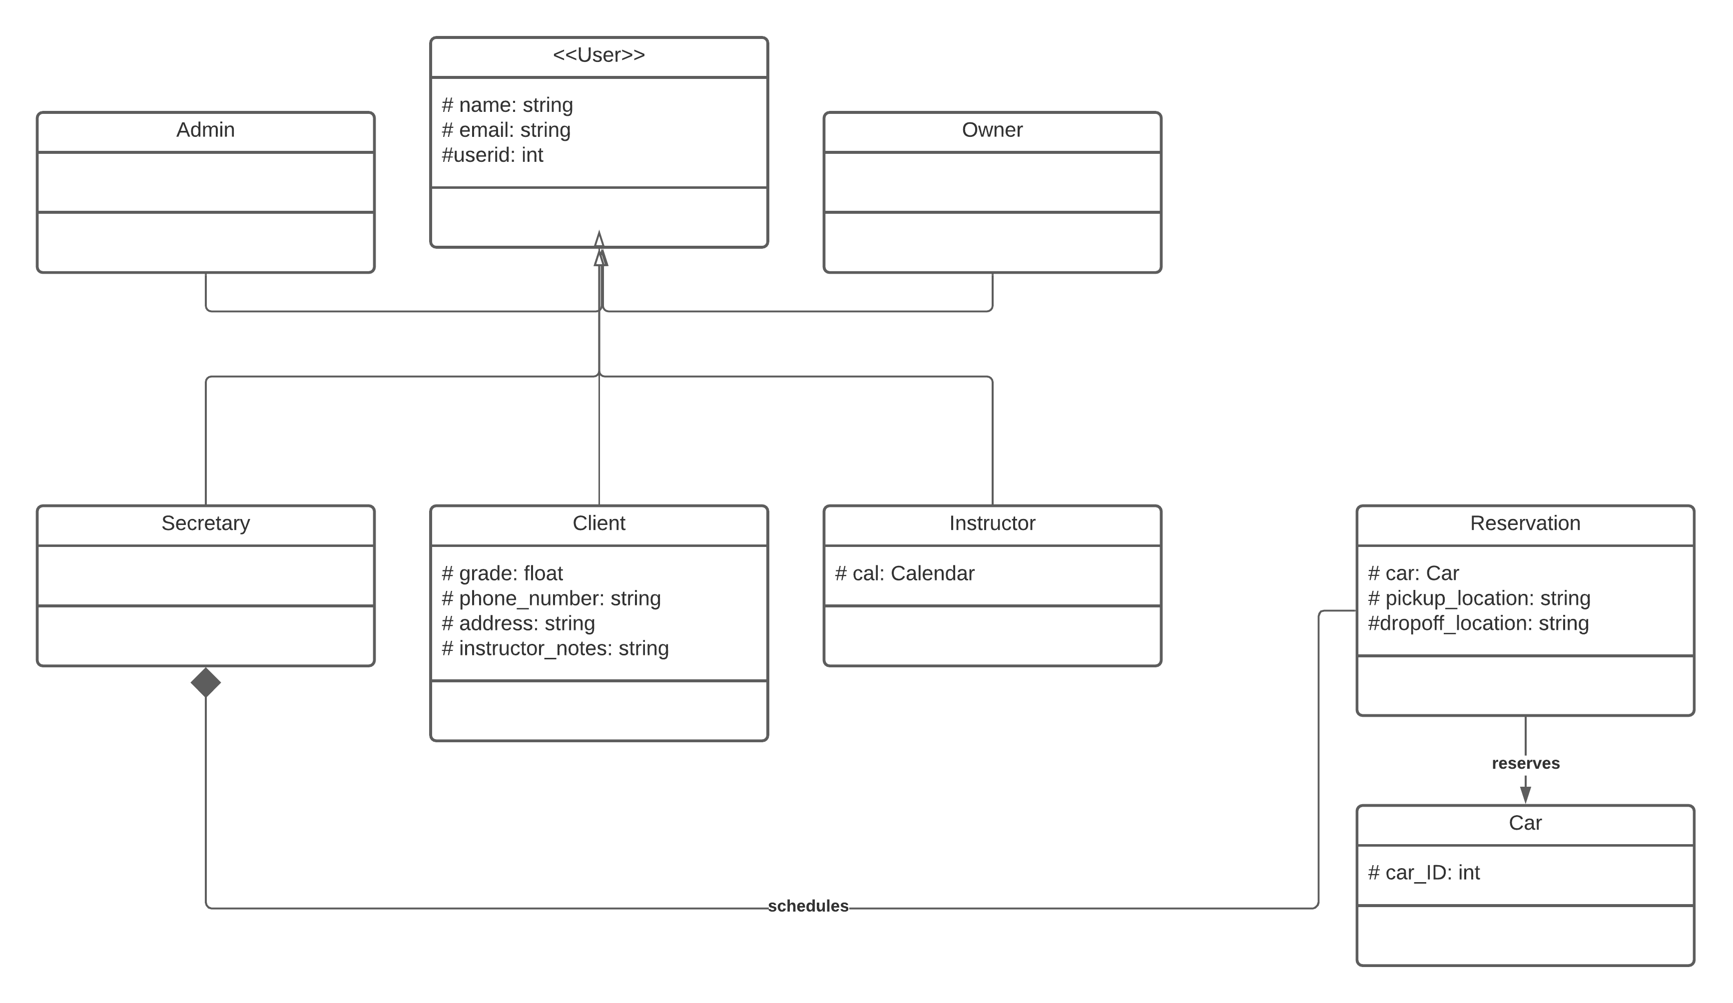

## Technical Requirements

* Android App
* iOS App
* Web Application
* Linux Server based in the United States
* HTTPS Web Server
* SSL Certificate
* PHP server-side application